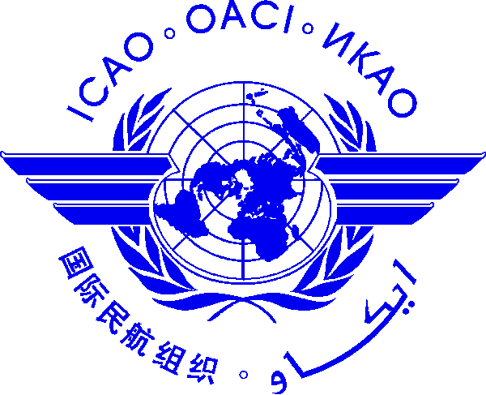 | International Civil Aviation Organization  WORKSHOP ON I) AERODROME OBSTACLE CHARTS (TYPE A AND TYPE B),  II) OBSTACLE LIMITATION SURFACES AND III) CHARTING HOT SPOTS  (30 JANUARY TO 1 FEBRUARY 2013, BANGKOK, THAILAND)

Nomination Form [please type or print]

State/ Organization
Name | Title |  | Family name (capitals) |  |  | First name |  |  | Middle initial
 | Mr/Dr/Ms.
Status |  | Principle Delegate |  |  | Delegate |  |  | Advisor
Official Position
Mailing Address
Telephone (office)
Fax
e-mail (1)
e-mail (2)
Hotel in Bangkok

Note 1: Participants are expected to make their own hotel/visa arrangements.
Note 2: All meeting material will be provided in soft copy (electronic) to participants.

Date ..........................……….... Signature ………….....………...
After completing, please send to: ICAO Regional Office for Asia and Pacific, P.O. Box 11, Samyaek Ladprao, Bangkok 10901, Thailand
Fax: 66 (2) 537 8199 or E-mail: APAC@icao.int by 20 January 2013.

